PRIMEHR SYSTEM
ADMIN USER MANUAL

Schools Division Office I Pangasinan
May 08, 2026

Table of Contents
1. Introduction
2. Dashboard and Navigation
3. 201 Files Management
4. Leave Management
5. Performance Forms
6. Office / Unit Management
7. User Profile
8. Best Practices and Reminders

1. Introduction
The PRIMEHR System is a centralized web-based Human Resource and Performance Management System designed for Schools Division Office I Pangasinan. This manual provides step-by-step instructions for administrators and system users.

2. 201 Files Document Types
This module allows administrators to manage required document types for employee 201 files. Users may add, update, delete, or review document requirements.
- Step 1: Open the module from the sidebar navigation.
- Step 2: Review the available records and information.
- Step 3: Use the action buttons to manage records.
- Step 4: Save updates or exports as needed.
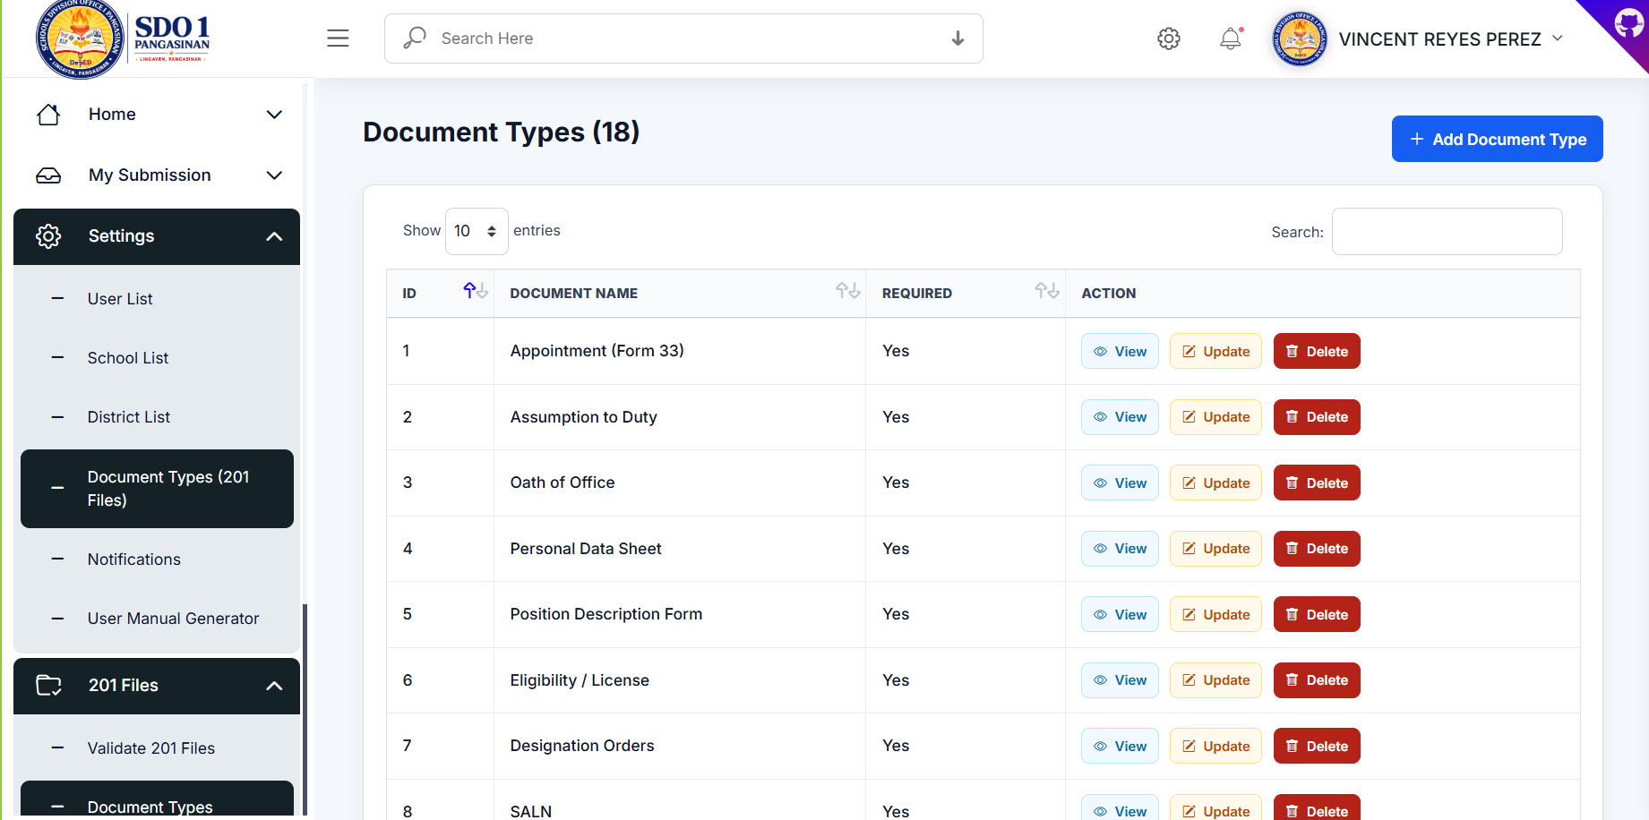
Note: Ensure that uploaded files are valid and user information is accurate before saving.

3. Leave Applications
The Leave Applications module allows administrators to review submitted leave requests, approve or reject applications, and monitor employee leave transactions.
- Step 1: Open the module from the sidebar navigation.
- Step 2: Review the available records and information.
- Step 3: Use the action buttons to manage records.
- Step 4: Save updates or exports as needed.
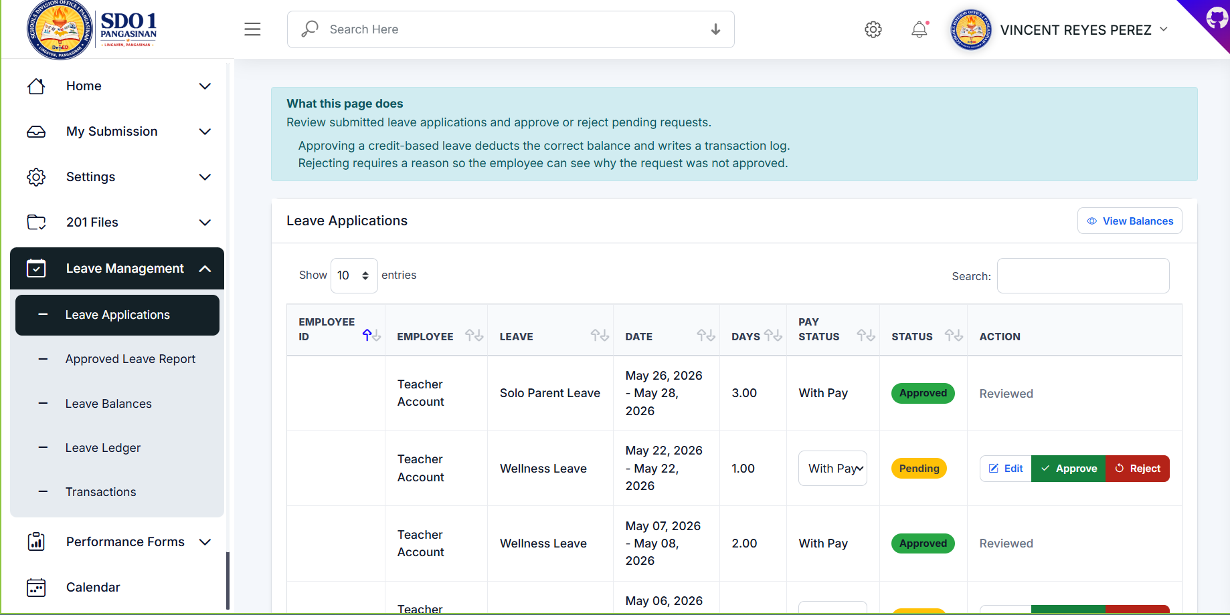
Note: Ensure that uploaded files are valid and user information is accurate before saving.

4. Approved Leave Report
This report displays approved leave applications with filtering and export functionality for CSV and PDF formats.
- Step 1: Open the module from the sidebar navigation.
- Step 2: Review the available records and information.
- Step 3: Use the action buttons to manage records.
- Step 4: Save updates or exports as needed.
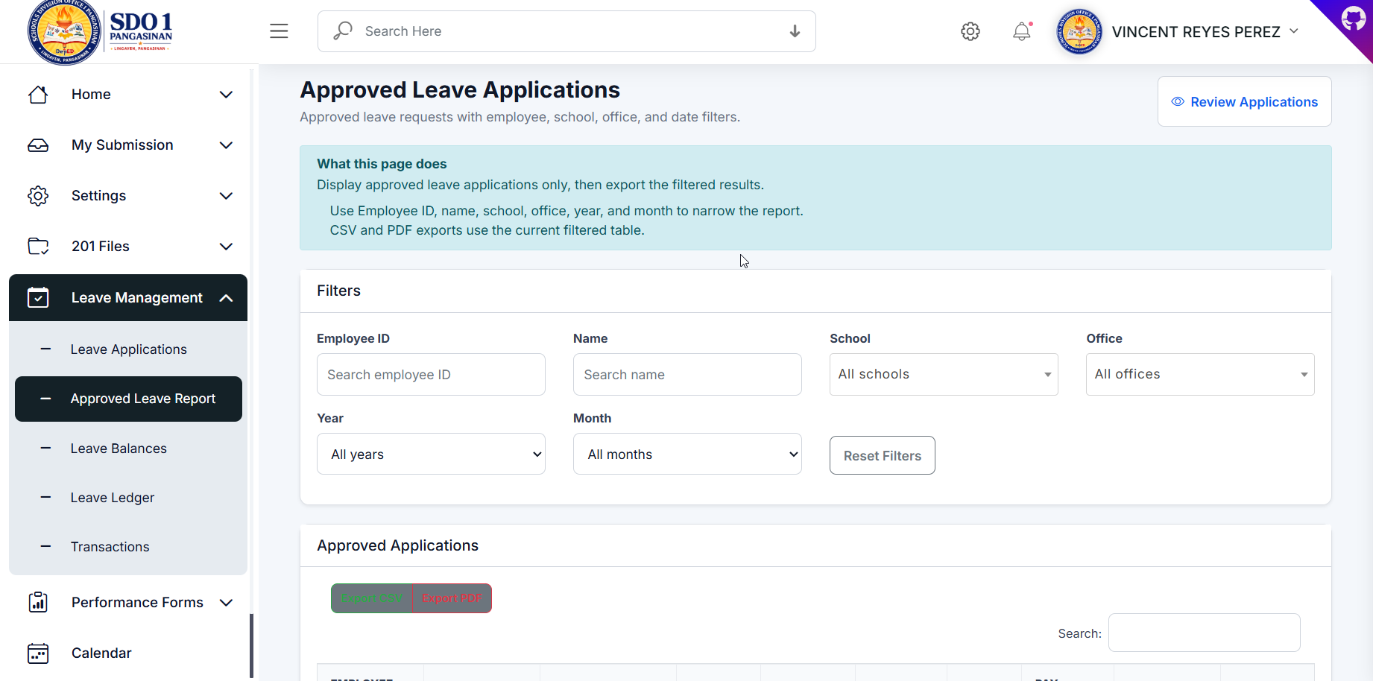
Note: Ensure that uploaded files are valid and user information is accurate before saving.

5. Leave Balances
Administrators can manually adjust employee leave balances and review current leave credits.
- Step 1: Open the module from the sidebar navigation.
- Step 2: Review the available records and information.
- Step 3: Use the action buttons to manage records.
- Step 4: Save updates or exports as needed.
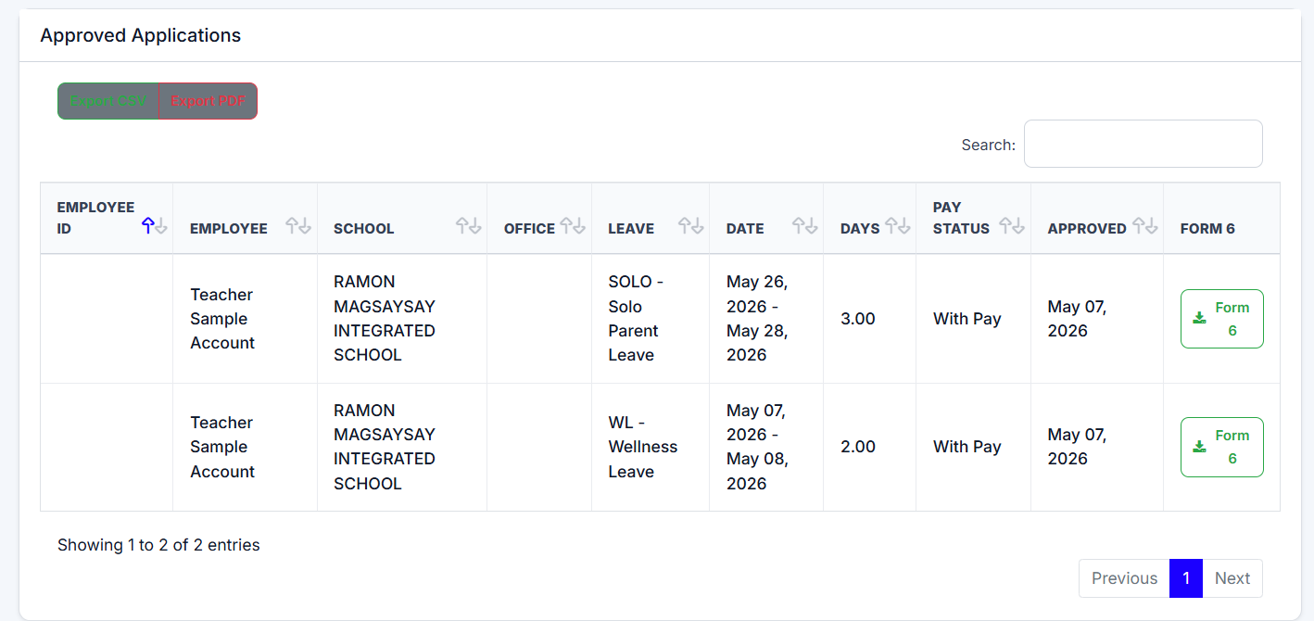
Note: Ensure that uploaded files are valid and user information is accurate before saving.

6. Leave Ledger
The Leave Ledger provides a detailed breakdown of earned, used, and remaining leave balances.
- Step 1: Open the module from the sidebar navigation.
- Step 2: Review the available records and information.
- Step 3: Use the action buttons to manage records.
- Step 4: Save updates or exports as needed.
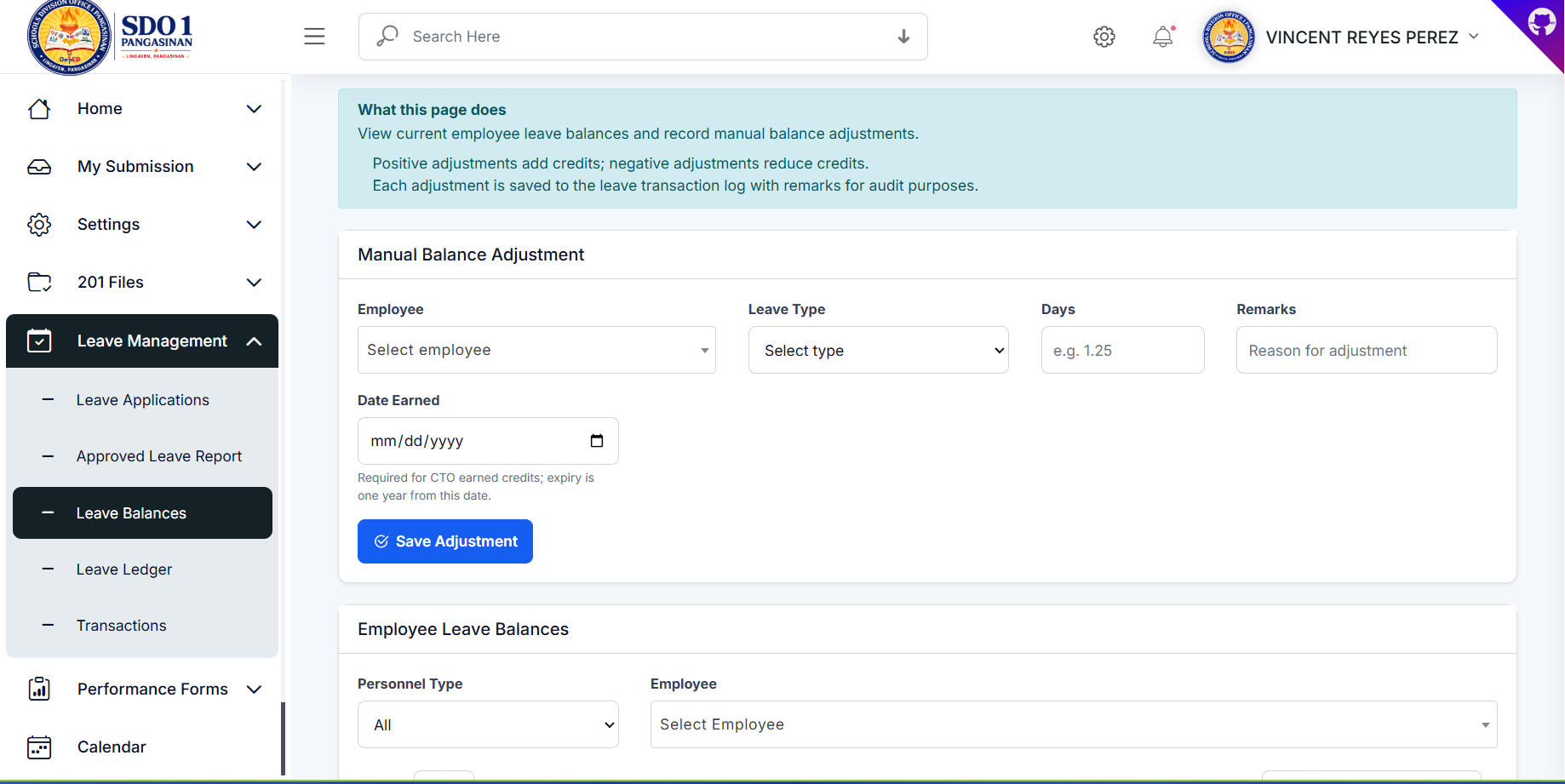
Note: Ensure that uploaded files are valid and user information is accurate before saving.

7. Leave Transactions
This page records all leave credit movements including adjustments, applications, and yearly updates.
- Step 1: Open the module from the sidebar navigation.
- Step 2: Review the available records and information.
- Step 3: Use the action buttons to manage records.
- Step 4: Save updates or exports as needed.
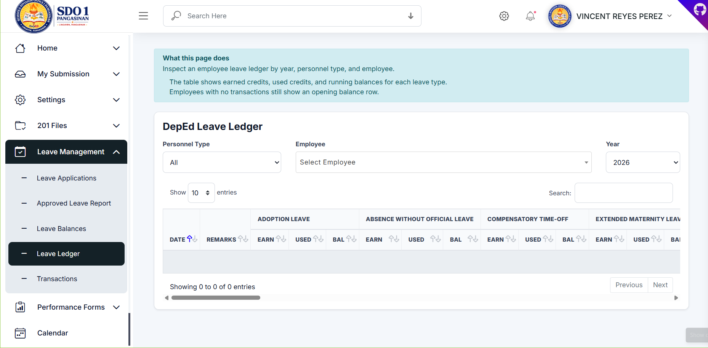
Note: Ensure that uploaded files are valid and user information is accurate before saving.

8. Office / Unit OPCRF
Administrators can create and monitor office-level OPCRF submissions and statuses.
- Step 1: Open the module from the sidebar navigation.
- Step 2: Review the available records and information.
- Step 3: Use the action buttons to manage records.
- Step 4: Save updates or exports as needed.
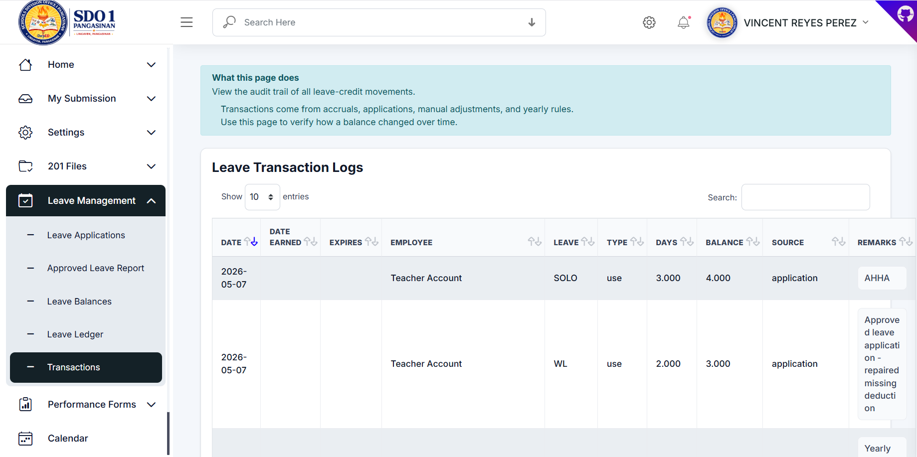
Note: Ensure that uploaded files are valid and user information is accurate before saving.

9. Create Office / Unit OPCRF
This modal allows users to upload OPCRF documents and define reporting details.
- Step 1: Open the module from the sidebar navigation.
- Step 2: Review the available records and information.
- Step 3: Use the action buttons to manage records.
- Step 4: Save updates or exports as needed.
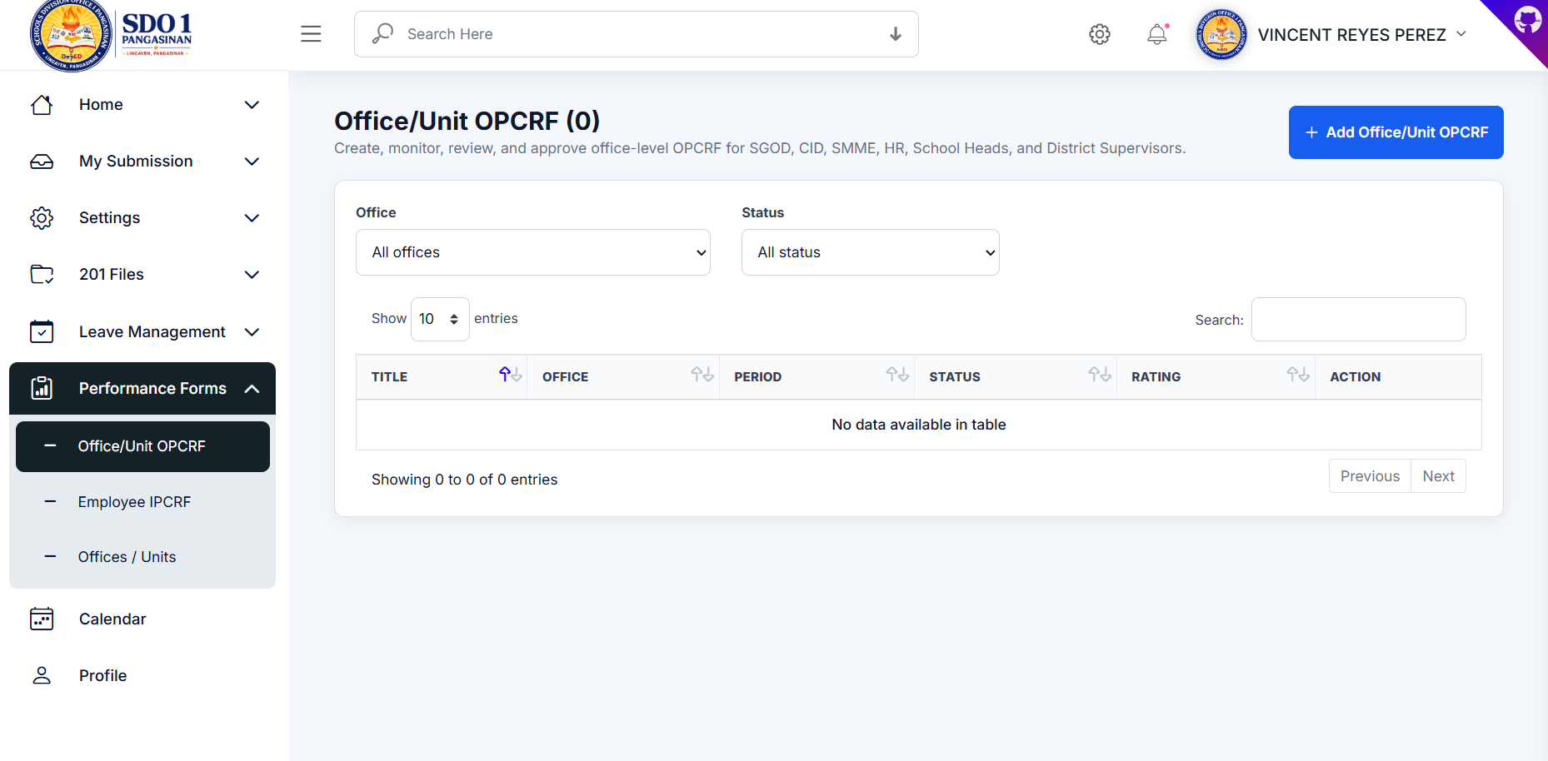
Note: Ensure that uploaded files are valid and user information is accurate before saving.

10. Employee IPCRF
The Employee IPCRF page is used to monitor employee submissions and approval workflows.
- Step 1: Open the module from the sidebar navigation.
- Step 2: Review the available records and information.
- Step 3: Use the action buttons to manage records.
- Step 4: Save updates or exports as needed.
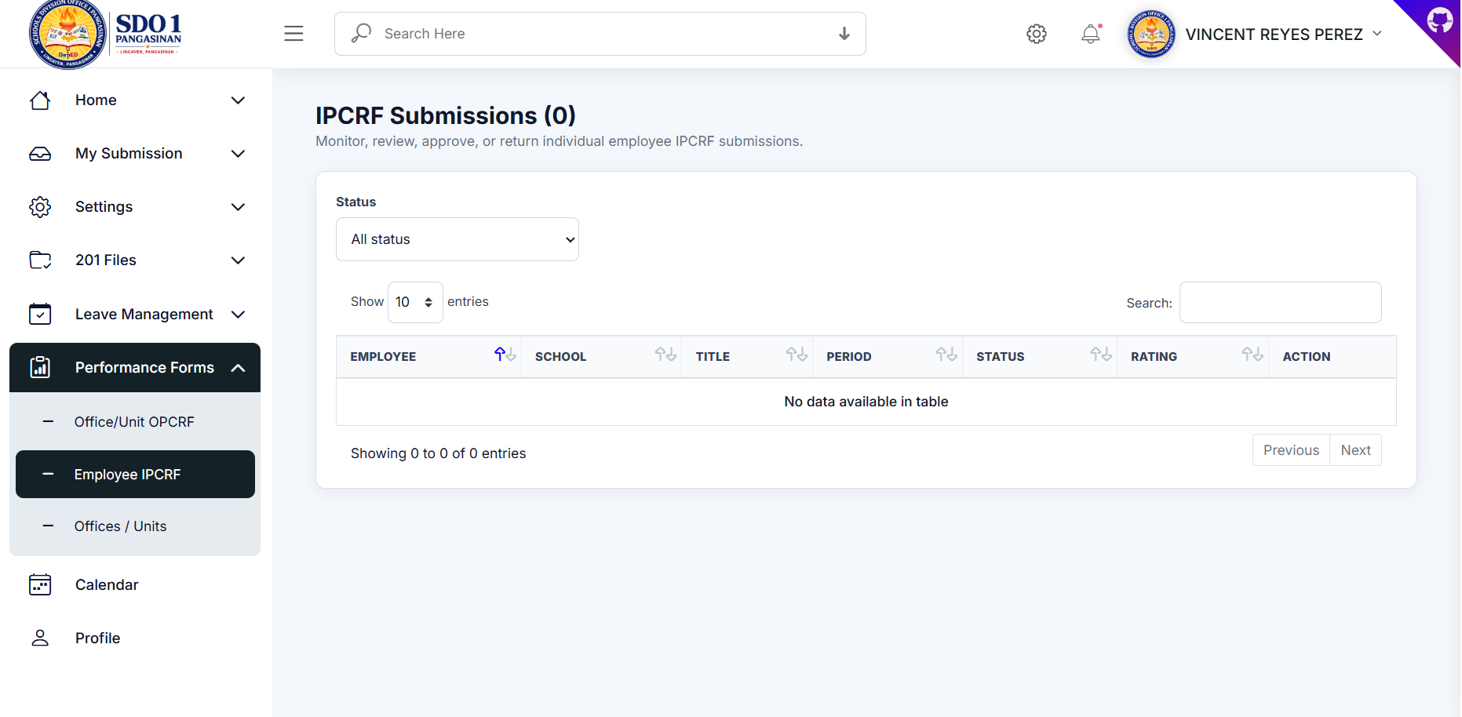
Note: Ensure that uploaded files are valid and user information is accurate before saving.

11. Offices / Units
This page manages office and unit information including office heads and OPCRF submitters.
- Step 1: Open the module from the sidebar navigation.
- Step 2: Review the available records and information.
- Step 3: Use the action buttons to manage records.
- Step 4: Save updates or exports as needed.
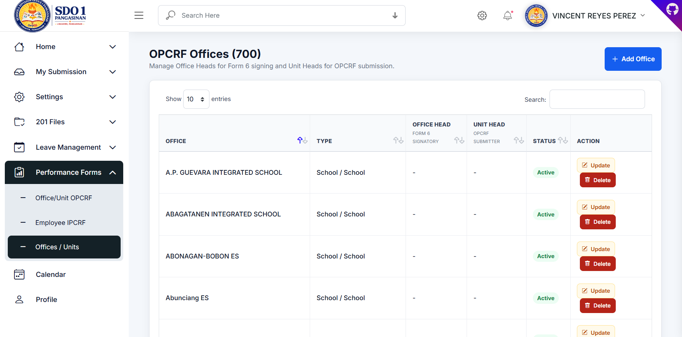
Note: Ensure that uploaded files are valid and user information is accurate before saving.

12. Add Office
Administrators may create office or school units and assign office heads and unit heads.
- Step 1: Open the module from the sidebar navigation.
- Step 2: Review the available records and information.
- Step 3: Use the action buttons to manage records.
- Step 4: Save updates or exports as needed.
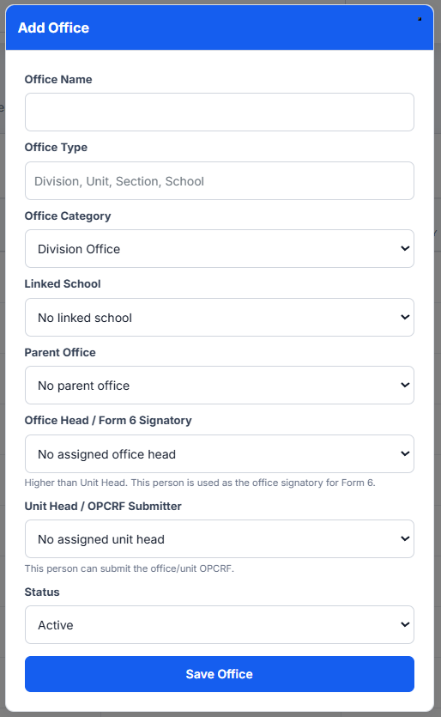
Note: Ensure that uploaded files are valid and user information is accurate before saving.

13. User Profile
The Profile module allows users to update personal and professional information.
- Step 1: Open the module from the sidebar navigation.
- Step 2: Review the available records and information.
- Step 3: Use the action buttons to manage records.
- Step 4: Save updates or exports as needed.
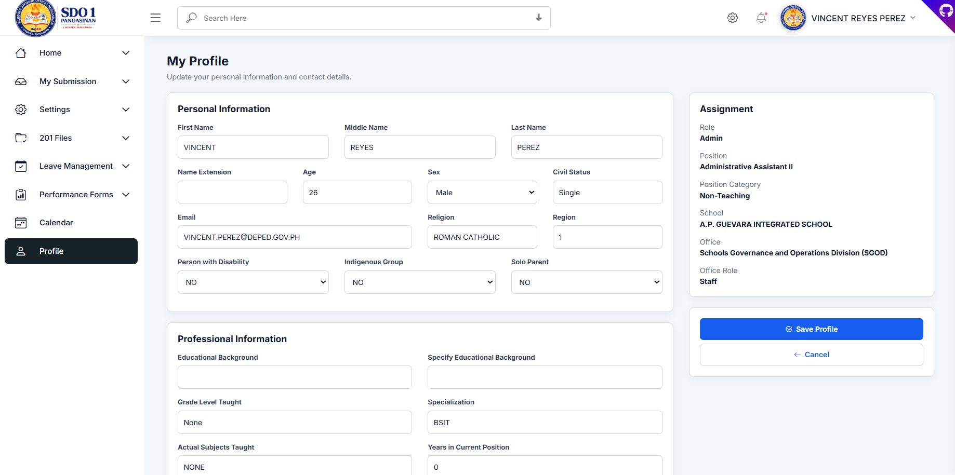
Note: Ensure that uploaded files are valid and user information is accurate before saving.

14. Best Practices and Reminders
- Always validate uploaded documents before approval.
- Review leave balances carefully before approving leave applications.
- Ensure office assignments and signatories are updated.
- Maintain updated employee profile information.
- Regularly back up the database and uploaded files.
End of Manual

